Chapter-1

Study of Existing system and system requirements.
Hardware & Software Requirement:

Hardware Interfaces
- Minimum Hardware requirement
- Processor: P4 3.0 GHz
- RAM:1 GB or Higher
- Monitor
- Mouse
- Hard disk: 80 GB

Software Interfaces
- Minimum Software requirement
- Java (JSP and Servlet)
- Spring Boot
- Hibernate
- Apache Tomcat Server

All these types of software automatic configure inside operating system after installation it having Java, MYSQL, Apache and operating system base configuration file, it doesn’t need to configure manually.

Introduction

In this digital world, The Attendance Marking system is a crucial requirement for any Organization. It is helpful in a way to track the student’s regularity for a particular course. It helps the Organization Admin to keep track of how regular the students are. Students on other hand can have a nice interface system where they can mark the enrollment for a course hassle-free.

In this web application, 3 roles: One is the Super Admin, another one is Admin and the last one is the normal user (students). The Super Admins’ responsibility is to manage all the other admin (i.e it can Approve | Cancel | Pending the New Admin Registration). Once the Admin is Approved, its responsibility will be adding Skills Set, Session, Trainer, View Enrollment, Mark the Attendance of a student who has attended the session as well as can view the report of Session and Feedback report as well. The last role is that of the user who can enroll for the session and give feedback.

This application will not only help the students but also to the bid educational organization where it is difficult to keep track of student attendance.

Objective
The main objective is to build a robust Attendance Marking System application for any organization to automate its Attendance taking process. It maintains all the records of users’ enrollment efficiently so that it would be easy to access at any time.

Here, the Super Admin who is the main user of this application whose responsibility is to manage all other admin. Then, adding the skill set, session, and marking is the responsibility of the Admin. The students here can enroll into sessions and also can give the feedbacks.

Methodologies
There are three main roles in this application, one is the Super Admin, another one is the Admin and the last one is the Student or normal user.
1) Super Admin
- Super Admin can VIEW the list of Admins registered.
- Super Admin can UPDATE/DELETE New Admin Requests.
2) Admin
- Admin can ADD/VIEW/UPDATE/DELETE Skill Set.
- Admin can ADD/VIEW/UPDATE/DELETE Sessions.
- Admin can ADD/VIEW/UPDATE/DELETE Trainers.
- Admin can VIEW/UPDATE/DELETE Enrollment.
- Admin can Mark the Attendance of the Student who had attained the session.
- Admin can VIEW the report of Session.
- Admin can VIEW the Feedback Report.
3) User (Student)
- Users can VIEW the Sessions.
- Users can Make the Enrollment for a Session.
- Users can VIEW the Session attended.
- Users can ADD/VIEW the Feedback.

Chapter-2
System Analysis
2.1 E R DIAGRAM
Data Flow Diagram (DFD)
Level 0:
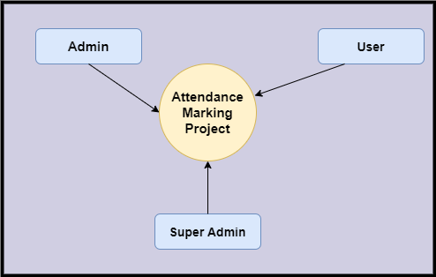
Level 1
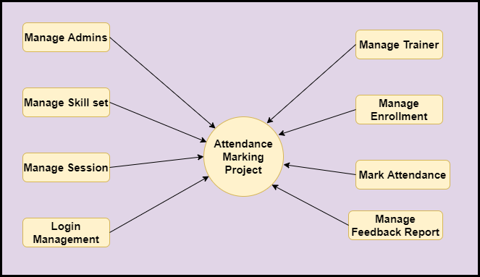
Level 2-DFD Super-Admin
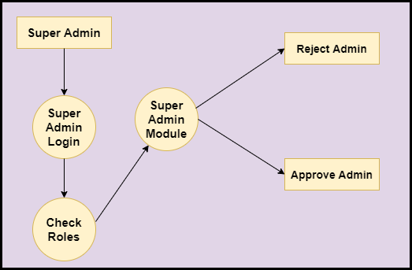
Level 2-DFD Admin
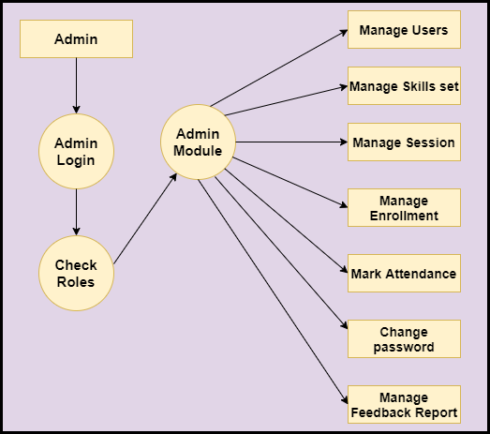
Level 2 –DFD User
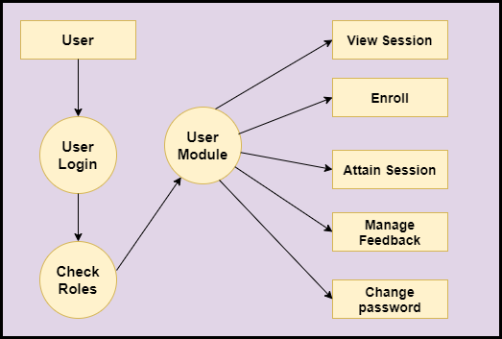

Feasibility:
This project will be developed on computer, so first check whether the technology is technically available or not. Now a day’s computer interaction with any job becomes common for any kind of job or work.

And because of increasing usage of Computer, Computer is also available with a variety of hardware. Vendors can fulfill any type of hardware requirement. The whole project is developed by some special tools or by using languages and databases, which are also available in a variety.

Preliminary investigation of a system examines the feasibility of a system that is useful to an organization. It is the first phase of system development.

The main objective of this phase is to identify the current deficiencies in the user’s environment and to determine which existing problem are going to be solve in proposed system and also which new function needs to be added in proposed system.

An important outcome of such preliminary investigation is to determine whether the system that will meet all needed requirements.

Thus, three tests are carried out on the system namely operation, technical and economical.

Any project is beneficial if and only satisfies the organization requirement. For any new system setup, it only meets to be communicated and work the other supporting system.

The new system meets all existing operations since it provides right information at a right time to the right user. A Leigh man can easily operate with the system.

Technical Feasibility examines whether the technology needed is available and if it is available then it feasible to carry out all project activities.

The technical needs of a system include:

- The facility to produce outputs in a given time.
- Ability to process large number of transaction at a particular speed.
- Giving response to users under certain conditions.

The technology needed for our system is mainly:

- Latest version of browsers.
- Any operating system.

These technologies are available which helps to carry out the system efficiently.

Economical feasibility of a system examines whether the finance is available for implementing the new system and whether the money spent is recoverable the satisfaction.

The cost involves is in designing and developing a good investment for the organization.

Thus, hardware requirements used for proposed system are very standard. Moreover, by making use of proposed system to carry out the work speedily will increase and also saves the valuable time of an organization.

In the proposed system the finance is highly required for the installation of the software’s which can also be recovered by implementing a better system.
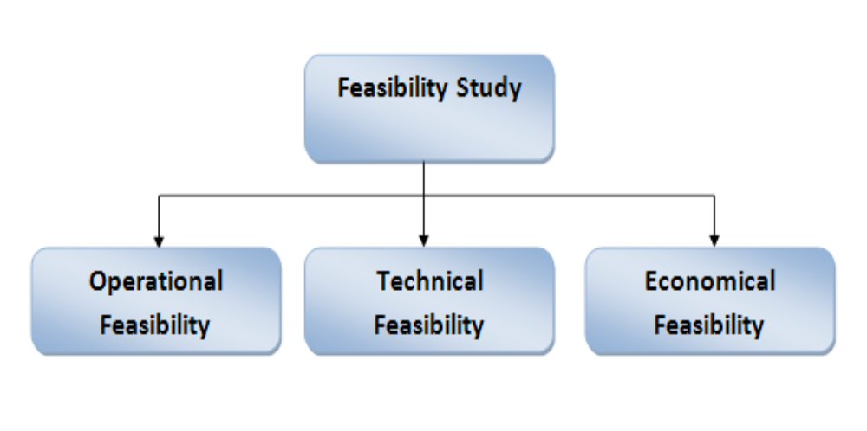

Chapter-3
Design
System Flow Chart:

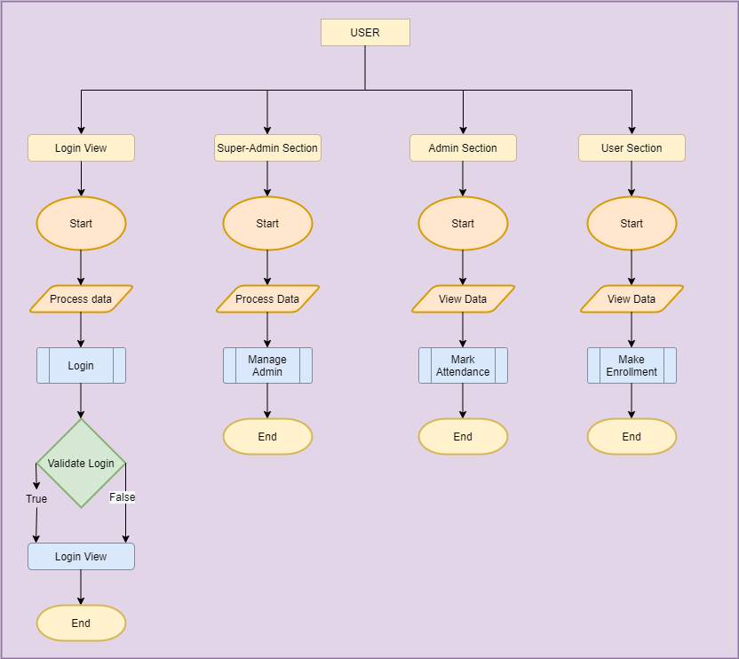

Data dictionary
Data validation:
Procedures are designed to detect errors in data at a lower level of detail. Data validations have been integrated in the system in almost every area where there is a possibility for the user to commit errors. The system will not recognize invalid data.
Whenever an invalid data is keyed in, the system immediately prompts the user and the user has to again key in the data and the system will accept the data only if the data is correct. Validations have been integrated where necessary.
The system is designed to be a user friendly one. In other words the system has been designed to communicate effectively with the user. The system has been designed with pop up menus.

Different Type Of validation:
- Data type validation;
- Range and constraint validation;
- Code and Cross-reference validation; and
Structured validation

Coding

Implementation and Testing:
Black-Box Testing:

Black Box Testing, also known as Behavioural Testing, is a software testing method in which the internal structure/ design/ implementation of the item being tested is not known to the tester. These tests can be functional or non-functional, though usually functional.

This can be following way:

- Input interfacing
- Processing
- Output interfacing
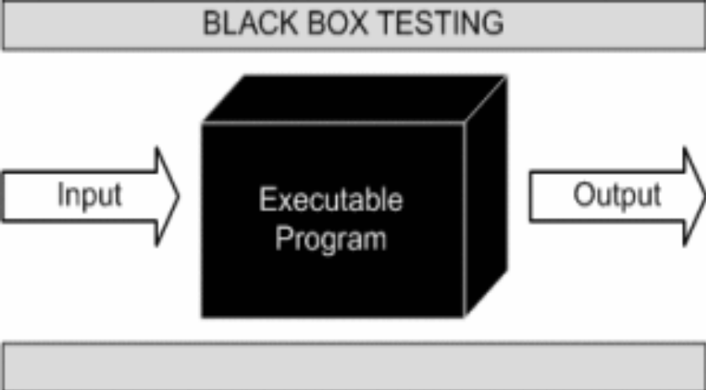

This method is named so because the software program, in the eyes of the tester, is like a black box; inside which one cannot see. This method attempts to find errors in the following categories:

- Incorrect or missing functions

- Interface errors

- Errors in data structures or external database access

- Behaviour or performance errors

- Initialization and termination errors.

White-Box Testing:

White Box Testing ,also known as Clear Box Testing, Open Box Testing, Glass Box Testing, Transparent Box Testing, Code-Based Testing or Structural Testing is a software testing method in which the internal structure/ design/ implementation of the item being tested is known to the tester.

The tester chooses inputs to exercise paths through the code and determines the appropriate outputs. Programming know-how and the implementation knowledge is essential.

White box testing is testing beyond the user interface and into the nitty-gritty of a system.
This method is named so because the software program, in the eyes of the tester, is like a white/ transparent box; inside which one clearly sees.

Limitations and Future Application of the Project

Futures Enhancement:
- In future we can expand this project on the web.
- In future, we can make add trainer module in the project.

Limitation :
In this, we can’t send email to user who is not attending session.

Screen Snapshot

Conclusion

Attendance Marking System Project is developed in such a way so that any organization whether it is big or small can use this application to keep the track of students who are enrolling for the session or not. This application helps students also to have a nice interface system where they can mark the enrollment for a course hassle-free.
The Super admin here takes care of adding any other admin. The Admin then can add the required skill set, session and see whether students has enrolled for the course or not and student can view skill sets and enroll for a session.
This application is designed in such a way that any future modification can be done most easily.

